DONATION PLATFORM
@CREATIVITY THINK (9483175986/7019689991)

ABSTRACT:
The Donation Platform is a web-based system developed to support charities, non-profit organizations, and fundraising initiatives by providing a centralized portal for campaign discovery and online donations. Users can register, browse active campaigns, make contributions, view donation history, and track their impact. Administrators manage campaigns, monitor donation analytics, oversee user activity, and send campaign updates. Built using Django and Django Rest Framework for backend operations and React with Chart.js for frontend visualization, the platform ensures reliable, secure, and transparent donation management. This system enhances accessibility, increases donor engagement, and improves operational efficiency for fundraising organizations..

INTRODUCTION OF THE PROJECT:
Non-profit organizations and charities require efficient systems for running fundraising campaigns, tracking contributions, and engaging donors. The Donation Platform provides a comprehensive solution by integrating campaign listings, online donation processing, user activity monitoring, and administrator dashboards. The backend uses Django for secure data handling while the frontend utilizes React for interactive components and Chart.js for donation analytics visualization. The platform improves transparency between organizations and donors, ensuring credibility and ease of access. Its intuitive design supports both donors and administrators in managing, monitoring, and optimizing fundraising operations..

PROJECT OBJECTIVES:

• To provide a centralized portal for hosting donation campaigns
• To allow users to register and make secure online contributions
• To display campaign details, donation progress, and impact metrics
• To equip administrators with tools to manage campaigns and user data
• To visualize donation analytics using interactive charts
• To enhance donor engagement through confirmations and updates
• To ensure secure, scalable management of fundraising data

PROBLEM OF THE STATEMENT:
Fundraising organizations often face challenges with transparency, donor engagement, and campaign management due to outdated or manual systems. Donors lack visibility into how their contributions are utilized, causing reduced trust and engagement. Administrators struggle to manage multiple campaigns, track donation metrics, and communicate effectively with supporters. The Donation Platform addresses these issues by providing a unified system for online contributions, campaign updates, and donation analytics. It improves transparency, builds donor trust, automates management tasks, and ensures efficient and data-driven fundraiser operations..

MOTIVATION OF THE PROJECT:
• Need for improved transparency in donation campaigns
• Increasing demand for digital fundraising platforms
• Difficulty in managing multiple donors and campaigns manually
• Growing preference for online contribution methods
• Necessity for real-time donation tracking and analytics

BLOCK DAIGRAM OF PROJECT:

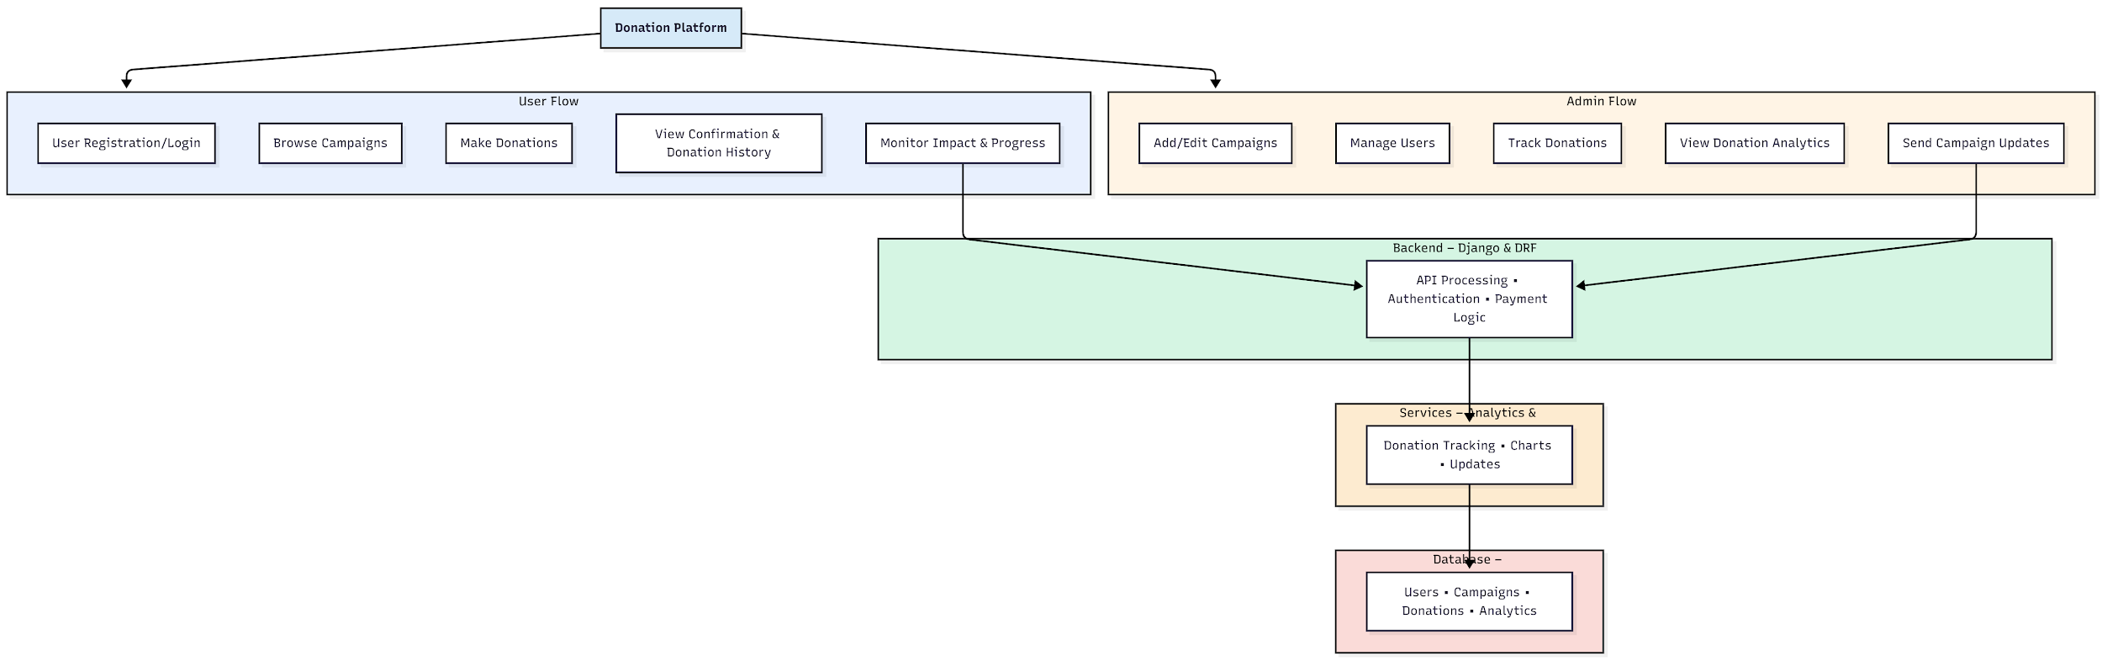

WORKING OF THE PROJECT:
Users begin by creating an account and accessing the campaign listings to explore ongoing fundraising initiatives. They can read campaign descriptions, contribute financially, and instantly receive confirmation notifications. The system records each contribution and updates donation progress charts in real time. Users can also view their donation history and track the impact of their contributions. Administrators add and edit campaigns, manage donors, monitor donation activity, analyze fundraising performance through interactive charts, and send updates to supporters. Django handles all backend processes, while React and Chart.js provide responsive and visually rich user interfaces..

SOFTWARE REQUIREMENT:
- Backend:
  - Python 3.x
  - Django
  - Django REST Framework
  - SQLite/PostgreSQL
- Frontend:
  - Node.js and npm
  - React.js
  - Axios
- Development Tools:
  - Visual Studio Code
  - Postman (for testing APIs)
  - Git/GitHub (for version control)
- Server/Deployment (Optional):
  - Gunicorn, Nginx, or Heroku/AWS for hosting

ADVANTAGES OF THE PROJECT:

• Increases transparency between donors and organizations
• Provides real-time donation analytics and visual tracking
• Simplifies campaign management for administrators
• Encourages user engagement through updates and confirmations
• Supports secure and convenient online donations
• Enhances credibility and trust for fundraising efforts
• Centralizes user, donation, and campaign data
• Reduces manual workload through automation

APPLICATIONS OF THE PROJECT:
• Charity fundraising platforms
• NGO and non-profit donation management
• Religious or community fundraising systems
• Disaster relief and emergency aid campaigns
• Medical and patient support fundraising
• Educational scholarship fundraising
• Crowdfunding campaigns for events or causes
• Awareness and social impact organizations

REFERENCES:

- Django REST Framework Documentation — Django Software Foundation. Django Documentation. Available: https://docs.djangoproject.com/
- Django REST Framework. DRF Documentation. Available: https://www.django-rest-framework.org/
- React. React Official Documentation. Available: https://reactjs.org/docs/getting-started.html
- Redux. Redux Documentation. Available: https://redux.js.org/introduction/getting-started
- PostgreSQL Global Development Group. PostgreSQL Documentation. Available: https://www.postgresql.org/docs/
- MySQL. MySQL Reference Manual. Available: https://dev.mysql.com/doc/
- Git. Git Documentation. Available: https://git-scm.com/doc
- Node.js. Node.js Documentation. Available: https://nodejs.org/en/docs/
- Axios. Axios Documentation. Available: https://axios-http.com/docs/intro
- Socket.io Documentation – https://socket.io/docs/

